# Levels of Organization

**Tissues**

**Cell**

**Tissue**

**Organ**

**Organ system**

**Organism**

* Various organ systems working simultaneously together constitute an organism. Example: Plants
* Different organs coordinate to perform a specific life process and form an organ system.

Example: Digestive system

* Different types of tissues working together and contributing to specific functions inside the body constitute an organ. Example: Stomach
* A tissue is a group of cells having a common origin, similar structure and function and held together by a cementing substance. Example: Connective tissue
* A cell is the basic structural and functional unit of a living organism. Example: Nerve cell

# Differences between Plant and Animal Tissues

|  |  |
| --- | --- |
| **PLANT TISSUES** | **ANIMAL TISSUES** |
| 1. Dead supportive tissues are more abundant as compared to living  tissues. | 1. Living supportive tissues are more abundant as compared to dead  tissues. |
| 2. Require less maintenance energy. | 2. Require more maintenance energy. |
| 3. Differentiation of meristematic and permanent tissues. | 3. No differentiation of meristematic and permanent tissues. |
| 4. Organisation is simple. | 4. Organisation is relatively complex. |
| 5. Tissue organisation is meant for stationary habit of plants. | 5. Tissue organisation is meant for high mobility of animals. |

**Classification of Plant Tissues**

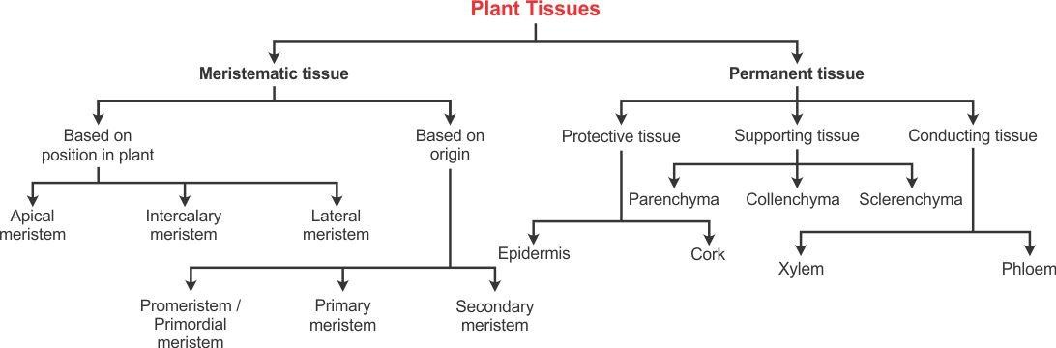

## Meristematic Tissue

* Cells are thin-walled and composed of cellulose.

**Characteristics**

* Located at the tips of the roots and stems, and the base of the node, internode or leaf.

**Location**

meristematic tissue divide actively, which results in growth (increase in thickness and length) of plants.

of

cells

* The

**Function**

### Types of Meristematic Tissues

|  |  |  |
| --- | --- | --- |
| **Type** | **Location** | **Function** |
| Apical meristem | Located at the growing points of the stem, roots, branches and in growing young leaves  near the tips of stems and axillary buds | Enables the root and stem to grow by increasing the length of  plants |
| Intercalary meristem | Located at the internodes or stem regions  between the places at which the leaves attach and at leaf bases | The cells are active and they  continuously form several new cells |
| Lateral meristem/ Cambium | Present laterally (on the sides) on the roots and stem and is situated parallel to the longitudinal axis below the bark | The girth and width/diameter/thickness of the stem or root increases because of  the lateral meristem |

**Permanent Tissues**

* Permanent tissues are formed by the division of the meristematic tissue cells which have lost their ability to multiply.

### Types of Permanent Tissues

#### Protective Tissue

* It is found on the surface of the roots, stems and leaves.
* It consists of cells with thick walls.
* It provides protection against mechanical injury or invasion by parasitic fungi.

|  |  |  |  |
| --- | --- | --- | --- |
| **Types of Protective Tissues** | | | |
| **Type** | **Characteristics** | **Location** | **Function** |
| Epidermis | Cells are elongated and flattened with no intercellular spaces between them. | Present in the outermost layer of leaves, flowers, stem and roots. | Protects the plant from desiccation and infection. |
| Cork | Cells are rectangular with vacuolated protoplasts. | It is the outermost layer formed after the epidermis undergoes certain changes. | Prevents desiccation, infection and mechanical injury. |

#### Supporting Tissue

* It provides support to the plant.

|  |  |  |  |
| --- | --- | --- | --- |
| **Types of Supporting Tissues** | | | |
| **Type** | **Characteristics** | **Location** | **Function** |
| Parenchyma | Consists of relatively non- specialised large, thin-walled living cells | Mainly present in the soft parts of the plant and outer cortical region of roots and  stems | Provides temporary support and maintains the shape of the plant  body |
| Collenchyma | Cells are living and elongated with cell walls irregularly thickened at the corners | Located in non-woody plants, leaf stalks and below the epidermis of the  stems and veins of leaves | Provides mechanical support and elasticity to young dicotyledonous  plants |
| Sclerenchyma | Consists of elongated, narrow and fibre-like cells.  Cells are dead, pointed at  both ends and thickened | Located in the stems around the vascular bundle, veins of leaves and hard  covering of seeds and nuts | Provides strength and toughness to plant parts |

#### Conducting Tissue (Vascular Tissue)

* It is present in stems, roots and leaves.
* It provides a passage for water and dissolved materials to move up and down in the plant body.

|  |  |  |  |
| --- | --- | --- | --- |
| **Types of Conducting Tissues** | | | |
| **Type** | **Characteristics** | **Location** | **Function** |
| Xylem | Complex permanent tissue with thick-walled cells; most of  the cells are dead | Present in the stem, roots and leaves | Provides upward movement of water and  dissolved materials |
| **Components of Xylem** | | | |
| Tracheids | Made of elongated cells with flat and tapering ends | - | Provide a network of hollow and connected cells for the transport of  water |
| Xylem vessels | Tubular structures which consist of dead cells | - | Allow free flow of water  and minerals from the roots to the leaves |
| Xylem  parenchyma | Consists of living parenchyma  cells associated with xylem | - | Stores food in the plant  body |
| Xylem fibres | Separated by thin cross walls | - | Mainly support the plant |
| **Types of Conducting Tissues** | | | |
| **Type** | **Characteristics** | **Location** | **Function** |
| Phloem | Complex permanent tissue | Lies just beneath the bark of the tree | Provides a passage for the downward movement  of food |
| **Components of Phloem** | | | |
| Sieve tubes | Tubular cells with perforated  walls and arranged end to end | - | Translocation of organic  substances |
| Companion cells | Cells are living and keep their nuclei and other organelles  throughout their life | - | Help to control the activity of sieve tube  elements |
| Phloem fibres | Elongated, tapering and dead  cells with thickened cell walls | Found particularly in the  stem | Provide mechanical  strength to plants |
| Phloem parenchyma | Cells are alive and filled with cytoplasm | - | Transports food from the leaves to the other non-  green parts of the plants |

# Differences between Meristematic and Permanent Tissues

|  |  |
| --- | --- |
| **MERISTEMATIC TISSUE** | **PERMANENT TISSUE** |
| 1. Simple tissue | 1. Simple, complex or specialised tissue |
| 2. Component cells are small, spherical or polygonal and undifferentiated | 2. Component cells are large, differentiated with different shapes |
| 3. Intercellular spaces are absent | 3. Intercellular spaces are present |
| 4. Cells grow and divide regularly | 4. Cells do not divide |
| 5. Metabolically active | 5. Metabolic rate is slow |
| 6. Provides growth to the plant | 6. Provides protection, support, conduction, photosynthesis, storage |

**Classification of Animal Tissues**

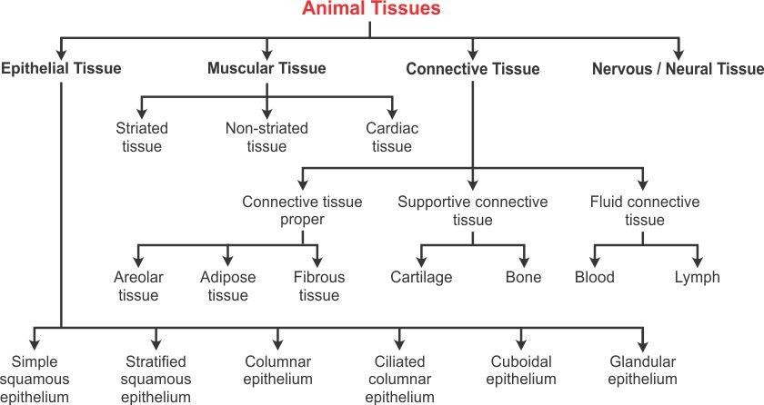

## Epithelial Tissue

columnar cells

or

cuboidal

* Flat,

**Characteristics**

* Covers the whole body

surface

**Location**

* Protection, absorption, secretion, sensory perception

**Function**

### Types of Epithelial Tissues

|  |  |  |  |
| --- | --- | --- | --- |
| **Type** | **Characteristics** | **Location** | **Function** |
| Simple squamous  epithelium | Cells are large, extremely thin and flat | Lining of blood vessels, lung alveoli, oesophagus, the lining of  the mouth and cheek | Transport of substances through a selectively  permeable membrane |
| Stratified squamous  epithelium | Cells are arranged in a pattern of layers | Outer protective covering all over the body surface | Provides protection to underlying tissues |
| Columnar  epithelium | Cells are tall and  cylindrical-like pillars | Inner lining of the  stomach and intestines | Absorption of nutrients from  the digested food |
| Ciliated columnar  epithelium | Cells possess fine hair-like cilia | Inner lining of the trachea, lungs, respiratory system and buccal  chambers | In the respiratory tract, the movement of cilia pushes the  mucus forward to clear it |
| Cuboidal epithelium | Cells are cube-shaped  and are placed on a basement membrane | Lining of the kidney tubules as well  as in the ducts of the salivary glands | Helps in the absorption of  useful material from urine before it is passed out |
| Glandular epithelium | Epithelial tissue which folds inwards to form  a multicellular gland | Present in the stomach, intestine and pancreas | Synthesis and secretion of substances at the epithelial  surface |

**Connective Tissue**

* Consists of a matrix and

the cells are embedded in it

**Characteristics**

* Found in the deeper parts of the body, between the skin and muscles

**Location**

* Connects various organs

and keeps them in place

**Function**

**Types of Connective Tissues**

#### Connective Tissue Proper/Loose Connective Tissue

* It is composed of irregular cells scattered and embedded in a soft matrix and encompasses all internal organs and body cavities.
* It acts as a binding and supporting structure within the body.

|  |  |  |  |
| --- | --- | --- | --- |
| **Types of Connective Tissues Proper** | | | |
| **Type** | **Characteristics** | **Location** | **Function** |
| Areolar tissue | Made of gelatinous matrix containing cells and irregularly arranged fibres | Found between the skin and muscles, around the blood vessels, nerves and in the bone  marrow | Supports and strengthens the internal organs |
| Adipose tissue | Cells are filled with fat globules | Found beneath the skin, around  the kidneys and other internal organs such as intestines | Insulates the body and prevents the loss of heat |
| Fibrous tissue | Mainly formed of fibre- forming cells, which form the tendons and ligaments | Found in the spaces between the bones and muscles | Tendons help to attach muscles to the bones. Ligaments serve to hold the structures together and keep  them strong and stable |

#### Supportive Connective Tissue/Dense Connective Tissue

* It is composed of fibres as its main matrix element and is found in bones and cartilages.
* It connects different tissues.

|  |  |  |  |
| --- | --- | --- | --- |
| **Types of Supportive Connective Tissues** | | | |
| **Type** | **Characteristics** | **Location** | **Function** |
| Cartilage | Non-porous, semi-  transparent and elastic tissue | Present in the nose, external ear,  trachea, larynx, ends of the long bones and between the vertebrae | Smoothens the bone surface  at joints, allowing smooth movement of these joints |
| Bone | Hard, strong and non- flexible porous tissue which consists of living  cells | Forms a rigid part of the skeletal system | Forms the supporting framework of the body Gives shape and rigidity to  the body |

#### Fluid Connective Tissue

* It consists of liquid as the ground substance and is present throughout the body.
* It provides nutrition, helps in transport of nutrients and gets rid of waste matter.

|  |  |  |  |
| --- | --- | --- | --- |
| **Types of Fluid Connective Tissues** | | | |
| **Type** | **Characteristics** | **Location** | **Function** |
| Blood | Red-coloured fluid matrix which consists of plasma and cells such  as RBCs, WBCs and platelets | Present throughout the body | Connects different parts of the body and establishes  continuity within the body |
| Lymph | Fluid surrounding the body cells which contains WBCs | Present throughout the body | Transports nutrients and  provides protection against diseases |

## Muscle Tissue

* Consists of elongated, narrow, muscle cells called muscle fibres

**Characteristics**

|  |  |  |  |
| --- | --- | --- | --- |
| **Location** | | | |
| * Mostly bones | attached | to | the |

* Helps in contraction and relaxation of the body

**Function**

### Types of Muscle Tissues

|  |  |  |  |
| --- | --- | --- | --- |
| **Type** | **Characteristics** | **Location** | **Function** |
| Striated/skeletal/ striped/voluntary  muscles | Muscle fibres are long, cylindrical, unbranched  and multinucleate | Found attached to the bones | Help in voluntary muscle movement and locomotion |
| Non-striated/ smooth/non-striped/ involuntary muscles | Muscle fibres are smooth and without striations | Found in the uterus, digestive tract, urinary bladder, iris of the eye, bronchi of the lungs and  other internal organs | Carry out movements which cannot be carried out by our conscious will |
| Cardiac/heart muscles | Muscle cells are short, cylindrical and have a single, centrally placed nucleus | Found only in the walls of the heart | Rhythmic contraction and relaxation of cardiac muscles help to pump and distribute the blood to  various parts of the body |

**Differences between Smooth, Skeletal and Cardiac Muscles**

|  |  |  |
| --- | --- | --- |
| **SMOOTH MUSCLE** | **SKELETAL MUSCLE** | **CARDIAC MUSCLE** |
| 1. Not striated | 1. Striated | 1. Striated |
| 2. Spindle-shaped | 2. Cylindrical | 2. Cylindrical |
| 3. Not branched | 3. Not branched | 3. Branched |
| 4. Nucleus - central | 4. Nuclei - peripheral | 4. Nuclei - central |
| 5. No discs | 5. No discs | 5. Intercalated discs |
| 6. Involuntary | 6. Voluntary | 6. Involuntary |
| 7. Slow | 7. Fast | 7. Fast |
| 8. Contraction not inherent | 8. Contraction not inherent | 8. Contraction inherent |

**Nervous/Neural Tissue**

* Made up of elongated cells called neurons
* Each neuron consists of three parts—cell body, axon and dendrites

**Characteristics**

* Component of the nervous system and encompasses the brain, spinal cord and nerves

**Location**

* Nerve cells mediate the transmission of messages from the brain to different parts of the body and vice versa

**Function**